**Cameroon Health Connect (CHC)**

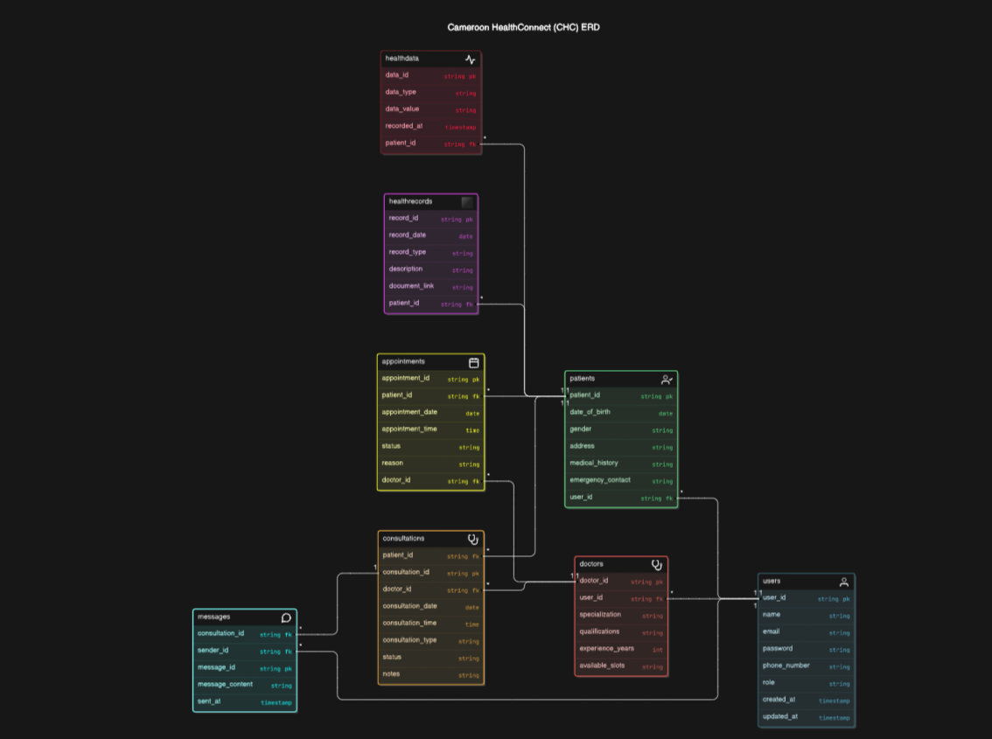**Schema design:**

For your Cameroon HealthConnect (CHC) project, you can indeed utilize the PERN stack, which consists of PostgreSQL, Express.js, React, and Node.js. Here’s a detailed breakdown of each technology and how they can be effectively used in your project:

1. **PostgreSQL**:

- **Role**: Database

- **Purpose**: Store all structured data, such as user information, patient records, consultation details, and health metrics.

- **Features**: Reliability, robustness, advanced indexing, and querying capabilities, support for JSON data types.

2. **Express.js**:

- **Role**: Backend Framework

- **Purpose**: Handle server-side logic, API creation, and routing.

- **Features**: Minimal and flexible, middleware support, easy integration with Node.js.

3. **React**:

- **Role**: Frontend Library

- **Purpose**: Build responsive, dynamic user interfaces for patients and healthcare professionals.

- **Features**: Component-based architecture, virtual DOM for efficient updates, strong ecosystem with libraries like Redux for state management.

4. **Node.js**:

- **Role**: Server Environment

- **Purpose**: Run server-side code and handle asynchronous operations.

- **Features**: Non-blocking I/O, event-driven architecture, wide range of modules available through npm.

### Additional Technologies to Consider:

- **Redux**: For managing complex state across your React application.

- **JWT (JSON Web Tokens)**: For secure authentication and authorization.

- **Socket.io**: For real-time communication features like live chat.

- **Docker**: For containerizing your application, making deployment easier.

- **AWS/Azure/GCP**: For hosting your application and managing additional cloud services like databases and storage.

This stack, along with these additional technologies, will provide a robust foundation for building your telemedicine platform, enabling you to deliver a scalable, efficient, and user-friendly service. If you need more specifics on integrating these technologies or have any other questions, feel free to ask! 🚀

Absolutely! Here are some recommended technologies for building your Cameroon HealthConnect (CHC) project, including Tailwind CSS for styling:

### Backend Technologies

1. **PostgreSQL**

- Role: Database

- Purpose: Store all structured data, such as user information, patient records, consultation details, and health metrics.

2. **Node.js**

- Role: Server Environment

- Purpose: Run server-side code and handle asynchronous operations.

3. **Express.js**

- Role: Backend Framework

- Purpose: Handle server-side logic, API creation, and routing.

4. **JWT (JSON Web Tokens)**

- Role: Authentication

- Purpose: Secure authentication and authorization.

5. **Socket.io**

- Role: Real-time Communication

- Purpose: Enable real-time features like live chat.

### Frontend Technologies

1. **React**

- Role: Frontend Library

- Purpose: Build responsive, dynamic user interfaces for patients and healthcare professionals.

2. **Redux**

- Role: State Management

- Purpose: Manage complex state across your React application.

3. **HTML/CSS**

- Role: Markup and Styling

- Purpose: Structure and style the user interface.

4. **Tailwind CSS**

- Role: Utility-First CSS Framework

- Purpose: Quickly build custom designs without writing custom CSS.

- Features: Highly customizable, responsive design, built-in utility classes for styling.

5. **Material-UI/Bootstrap**

- Role: UI Components (Optional)

- Purpose: Provide pre-designed UI components to speed up development.

- Features: Extensive set of reusable components, consistent design system, responsive layout.

### Additional Tools and Technologies

1. **Docker**

- Role: Containerization

- Purpose: Containerize your application, making it easier to deploy and manage across different environments.

2. **AWS/Azure/GCP**

- Role: Cloud Services

- Purpose: Host your application, manage databases, and utilize additional cloud services such as storage and scaling.

3. **GraphQL**

- Role: API Query Language (Optional)

- Purpose: Provide a more efficient and flexible way to query and manage data compared to traditional REST APIs.

4. **TypeScript**

- Role: Superset of JavaScript

- Purpose: Add static types to JavaScript, making the codebase more robust and easier to manage.

5. **Nginx**

- Role: Web Server

- Purpose: Serve static files, reverse proxy, load balancing, and improve performance and security.

By integrating these technologies, you'll be able to build a robust, scalable, and efficient telemedicine platform. Tailwind CSS will help you rapidly design a clean and consistent user interface, while other tools like Docker and cloud services will ensure smooth deployment and scalability.

If you need more details on how to set up or integrate these technologies, feel free to ask! 🌟

Certainly! Cameroon HealthConnect (CHC) is a comprehensive telemedicine and digital health platform aimed at transforming healthcare delivery in Cameroon. Here’s a detailed explanation of the project:

### Project Overview

Cameroon HealthConnect (CHC) is designed to bridge the gap between patients and healthcare professionals by leveraging modern technologies. The platform aims to enhance the accessibility, affordability, and quality of healthcare services, particularly for underserved communities in Cameroon.

### Project Objectives:

1. **Provide Accessible and Affordable Healthcare**:

- CHC aims to reach underserved communities by offering healthcare services through a digital platform. This approach reduces the need for physical travel and lowers costs, making healthcare more accessible and affordable.

2. **Improve Healthcare Outcomes**:

- Through timely consultations and continuous monitoring, CHC ensures patients receive prompt medical attention, which can lead to better health outcomes.

3. **Enhance Patient Engagement and Empowerment**:

- The platform engages patients by providing them with tools and information to take charge of their health. Features like health information hubs and virtual assistant chatbots educate and guide patients in managing their health.

4. **Foster Collaboration Among Healthcare Professionals**:

- CHC facilitates communication and collaboration among doctors, nurses, and other healthcare professionals, enabling them to share knowledge, discuss cases, and provide comprehensive care.

5. **Generate Valuable Health Data Insights**:

- By collecting and analyzing health data, CHC provides insights that can inform decision-making, improve treatment plans, and contribute to public health research.

### Key Features:

1. **Telemedicine (Video/Audio Consultations)**:

- Patients can consult with healthcare professionals via video or audio calls, making it easier to receive medical advice and treatment without the need for in-person visits.

2. **Electronic Health Records (EHRs)**:

- EHRs enable the digital storage and retrieval of patient health records, ensuring that healthcare providers have access to accurate and up-to-date medical histories.

3. **AI-powered Clinical Decision Support**:

- AI technologies assist healthcare providers in diagnosing conditions, recommending treatments, and predicting patient outcomes, thereby improving the accuracy and efficiency of care.

4. **Virtual Assistant Chatbots**:

- Chatbots provide 24/7 support to patients, answering questions, scheduling appointments, and offering health advice. This enhances patient engagement and streamlines administrative tasks.

5. **Health Information Hub**:

- A centralized repository of health information, resources, and educational content helps patients and healthcare providers stay informed about health topics and best practices.

6. **Doctor Directory and Appointment Scheduling**:

- Patients can search for doctors based on specialization, location, and availability, and easily schedule appointments through the platform.

7. **Secure Payment Gateway**:

- A secure payment system ensures that transactions for healthcare services are safe and convenient, supporting various payment methods.

### Conclusion

Cameroon HealthConnect (CHC) is poised to revolutionize healthcare in Cameroon by making it more accessible, efficient, and patient-centric. By leveraging cutting-edge technologies, the platform addresses critical healthcare challenges and aims to deliver better health outcomes for all.

If you need more details or have any specific questions about any part of the project, feel free to ask! 🚀

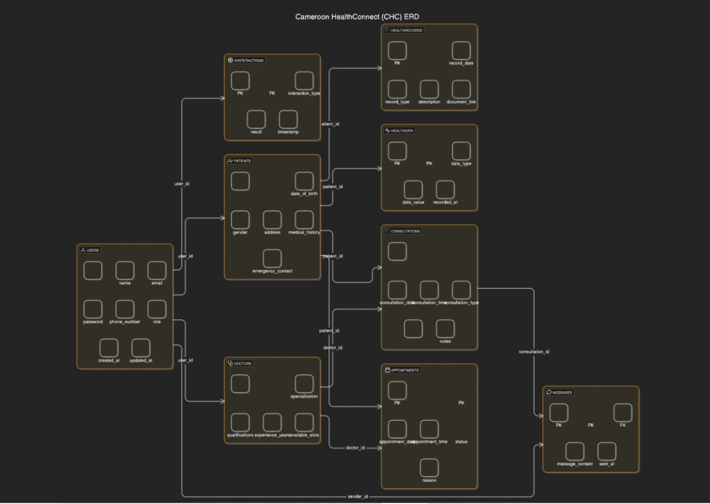

Sure! Here's a list of the technologies you'll need for the Cameroon HealthConnect (CHC) project, organized by backend, frontend, AI integration, and additional tools:

### Backend Technologies:

1. **Node.js**: Server environment to run server-side code and handle asynchronous operations.

2. **Express.js**: Backend framework for server-side logic, API creation, and routing.

3. **PostgreSQL**: Database for storing structured data such as user information, patient records, consultation details, and health metrics.

4. **JWT (JSON Web Tokens)**: For secure authentication and authorization.

5. **Socket.io**: For enabling real-time features like live chat.

6. **Sequelize**: ORM (Object-Relational Mapping) tool for managing and interacting with the PostgreSQL database.

### Frontend Technologies:

1. **React**: Frontend library for building responsive, dynamic user interfaces.

2. **Redux**: For managing complex state across your React application.

3. **Tailwind CSS**: Utility-first CSS framework for quickly building custom designs without writing custom CSS.

4. **Material-UI/Bootstrap**: Optional UI component libraries to provide pre-designed UI components and speed up development.

5. **HTML/CSS**: Standard web technologies for building and styling web pages.

### AI Integration Technologies:

1. **TensorFlow.js / PyTorch**: For implementing AI models that can run in the browser or backend.

2. **OpenAI GPT-3**: For natural language processing tasks, such as virtual assistants and chatbots.

3. **scikit-learn**: For traditional machine learning algorithms and models.

4. **NLTK / spaCy**: For natural language processing and text analysis.

### Additional Tools and Technologies:

1. **Docker**: For containerizing the application, making deployment easier and consistent across different environments.

2. **AWS/Azure/GCP**: Cloud services for hosting the application, managing databases, storage, and additional cloud services.

3. **GraphQL**: Optional API query language for more efficient and flexible data querying compared to traditional REST APIs.

4. **TypeScript**: Superset of JavaScript that adds static types, making the codebase more robust and easier to manage.

5. **Nginx**: Web server for serving static files, reverse proxy, load balancing, and improving performance and security.

### Project Structure Summary:

- **Backend**: Node.js, Express.js, PostgreSQL, JWT, Socket.io, Sequelize

- **Frontend**: React, Redux, Tailwind CSS, Material-UI/Bootstrap, HTML/CSS

- **AI Integration**: TensorFlow.js / PyTorch, OpenAI GPT-3, scikit-learn, NLTK / spaCy

- **Additional Tools**: Docker, AWS/Azure/GCP, GraphQL, TypeScript, Nginx

These technologies will help you build a robust, scalable, and efficient telemedicine and digital health platform. If you need more details on how to set up or integrate these technologies, feel free to ask! 🚀

Certainly! Here's a comprehensive file structure for your Cameroon HealthConnect (CHC) project, which incorporates the backend, frontend, AI integration, and other essential components:

### Project Root

```

/chc-project

├── /backend

├── /frontend

├── .gitignore

├── package.json

├── README.md

├── docker-compose.yml

```

### Backend Structure (Node.js + Express + PostgreSQL + AI)

```

/backend

├── /config

│ ├── db.js // Database configuration

│ ├── aiConfig.js // AI configuration and setup

├── /controllers

│ ├── authController.js // Authentication logic

│ ├── userController.js // User-specific logic

│ ├── patientController.js // Patient-specific logic

│ ├── doctorController.js // Doctor-specific logic

│ ├── consultationController.js // Consultation logic

│ ├── healthRecordController.js // Health record logic

│ ├── appointmentController.js // Appointment logic

│ ├── messageController.js // Messaging logic

│ ├── healthDataController.js // Health data logic

│ ├── aiController.js // AI-related logic (e.g., AI-powered symptom checker)

├── /middleware

│ ├── authMiddleware.js // Authentication middleware

├── /models

│ ├── User.js // User schema

│ ├── Patient.js // Patient schema

│ ├── Doctor.js // Doctor schema

│ ├── Consultation.js // Consultation schema

│ ├── HealthRecord.js // Health record schema

│ ├── Appointment.js // Appointment schema

│ ├── Message.js // Message schema

│ ├── HealthData.js // Health data schema

├── /routes

│ ├── authRoutes.js // Authentication routes

│ ├── userRoutes.js // User routes

│ ├── patientRoutes.js // Patient routes

│ ├── doctorRoutes.js // Doctor routes

│ ├── consultationRoutes.js // Consultation routes

│ ├── healthRecordRoutes.js // Health record routes

│ ├── appointmentRoutes.js // Appointment routes

│ ├── messageRoutes.js // Messaging routes

│ ├── healthDataRoutes.js // Health data routes

│ ├── aiRoutes.js // AI-related routes (e.g., symptom checker API)

├── /utils

│ ├── logger.js // Logger utility

├── /services

│ ├── aiService.js // AI service logic

├── server.js // Entry point for the backend server

├── .env // Environment variables

├── package.json

├── Dockerfile // Docker configuration for backend

```

### Frontend Structure (React + Redux + Tailwind CSS + AI Integration)

```

/frontend

├── /public

│ ├── index.html // HTML template

├── /src

│ ├── /assets

│ │ ├── /images // Image assets

│ ├── /components

│ │ ├── Header.js // Header component

│ │ ├── Footer.js // Footer component

│ │ ├── Sidebar.js // Sidebar component

│ │ ├── Dashboard.js // Dashboard component

│ │ ├── PatientProfile.js // Patient profile component

│ │ ├── DoctorProfile.js // Doctor profile component

│ │ ├── Consultation.js // Consultation component

│ │ ├── Appointment.js // Appointment component

│ │ ├── Chat.js // Chat component

│ │ ├── SymptomChecker.js // AI-powered symptom checker component

│ ├── /pages

│ │ ├── HomePage.js // Home page

│ │ ├── LoginPage.js // Login page

│ │ ├── RegisterPage.js // Registration page

│ │ ├── PatientPage.js // Patient-specific page

│ │ ├── DoctorPage.js // Doctor-specific page

│ │ ├── ConsultationPage.js // Consultation page

│ │ ├── AppointmentPage.js // Appointment page

│ ├── /redux

│ │ ├── store.js // Redux store

│ │ ├── rootReducer.js // Root reducer

│ │ ├── /slices // Redux slices

│ │ │ ├── authSlice.js

│ │ │ ├── userSlice.js

│ │ │ ├── patientSlice.js

│ │ │ ├── doctorSlice.js

│ │ │ ├── consultationSlice.js

│ │ │ ├── appointmentSlice.js

│ │ │ ├── messageSlice.js

│ │ │ ├── healthDataSlice.js

│ │ │ ├── aiSlice.js // AI-related state management

│ ├── /styles

│ │ ├── tailwind.css // Tailwind CSS configuration

│ ├── App.js // Main application component

│ ├── index.js // Entry point for React

├── tailwind.config.js // Tailwind CSS configuration file

├── postcss.config.js // PostCSS configuration file

├── package.json

├── Dockerfile // Docker configuration for frontend

```

### Explanation:

- **Backend**:

- **Config**: Database and AI configuration.

- **Controllers**: Logic for authentication, users, patients, doctors, consultations, health records, appointments, messages, health data, and AI.

- **Middleware**: Authentication middleware.

- **Models**: Database schemas.

- **Routes**: API routes.

- **Utils**: Utility functions like logging.

- **Services**: AI service logic.

- **Server.js**: Entry point for the backend server.

- **Dockerfile**: Docker configuration for containerizing the backend.

- **.env**: Environment variables.

- **Frontend**:

- **Public**: Static assets like the HTML template.

- **Src**: Source code.

- **Assets**: Images and other static assets.

- **Components**: React components.

- **Pages**: Specific pages for different routes.

- **Redux**: State management with Redux.

- **Styles**: Tailwind CSS configuration and styles.

- **App.js**: Main application component.

- **Index.js**: Entry point for React.

- **Tailwind.config.js**: Tailwind CSS configuration.

- **Postcss.config.js**: PostCSS configuration.

- **Dockerfile**: Docker configuration for containerizing the frontend.

This structure will help you organize your project effectively, making it easier to manage, develop, and scale. If you have any specific requirements or need further assistance, feel free to ask! 🚀

Resources

<https://www.figma.com/design/KPrHZhKHJiz3wV3slC5ZMc/Health-Hub-Landing-Page-(Community)?node-id=11237-631&node-type=canvas&t=yyyXJsfkUemaOU81-0>

<https://www.figma.com/design/S6i5wk2XlV862R12xBtkmY/HealthyMe---HealthCare-Web-UI-(Community)?node-id=0-1&node-type=canvas&t=TQEO6jrc5fFT9lrV-0>